**Calculating Family Expenses Using Service Now**

**Team Id**: NM2025TMID13178

**Team Members**: 4

Team Leader: r. roobini

Team Member 1: S. SHARMI

Team Member 2: S. NARMADHA

Team Member 3: K. DIVYA

# **Problem Statement:**

Families often struggle to track and manage their monthly expenses due to scattered data sources, manual record-keeping, and lack of real-time insights. This leads to overspending, missed savings opportunities, and financial stress. There is a need for a centralized, automated, and user-friendly system to monitor, categorize, and analyze family expenses.

# **Objective:**

1. **Centralize Expense Tracking:** Create a single platform to log all family expenses.
2. **Automate Categorization:** Use workflows to automatically classify expenses (e.g., groceries, utilities, education).
3. **Enable Real-Time Reporting:** Provide dashboards and reports for monthly, quarterly, and yearly expense summaries.
4. **Set Budget Thresholds:** Alert users when spending exceeds predefined limits.
5. **Improve Financial Awareness:** Help families make informed decisions through data-driven insights.

**Skills:**

* ServiceNow Development
* JavaScript & Glide Scripting
* UI/UX Design
* Data Analysis

**TASK INITIATION**

## **Milestone 1: Setting Up Service Now Instance**

## **Activity 1:** Sign Up to the Instance

1. Open a new browser tab.
2. Go to <https://developer.servicenow.com>.
3. Log in to your account.
4. Navigate to "Personal Developer Instance".
5. Click on "Request Instance".
6. Once the instance is ready, click "Open Instance".

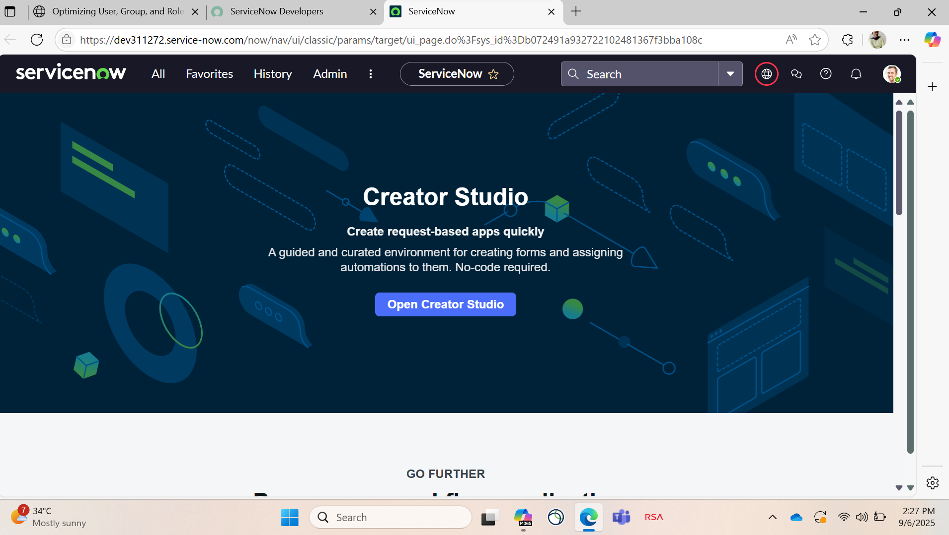

# **Milestone 2: New Update Set**

## **Activity 1:** **Creation of New Update Set**

1. Click on "All" in the Application Navigator.
2. Search for "Local Update Set" in the filter navigator.
3. Select "Local Update Set" under the System Update Sets module.
4. Click on "New" to create a new update set.
5. Fill in the details as follows:
6. Name: Family Expenses
7. Click "Submit".
8. After submission, click "Make Current" to activate the update set.

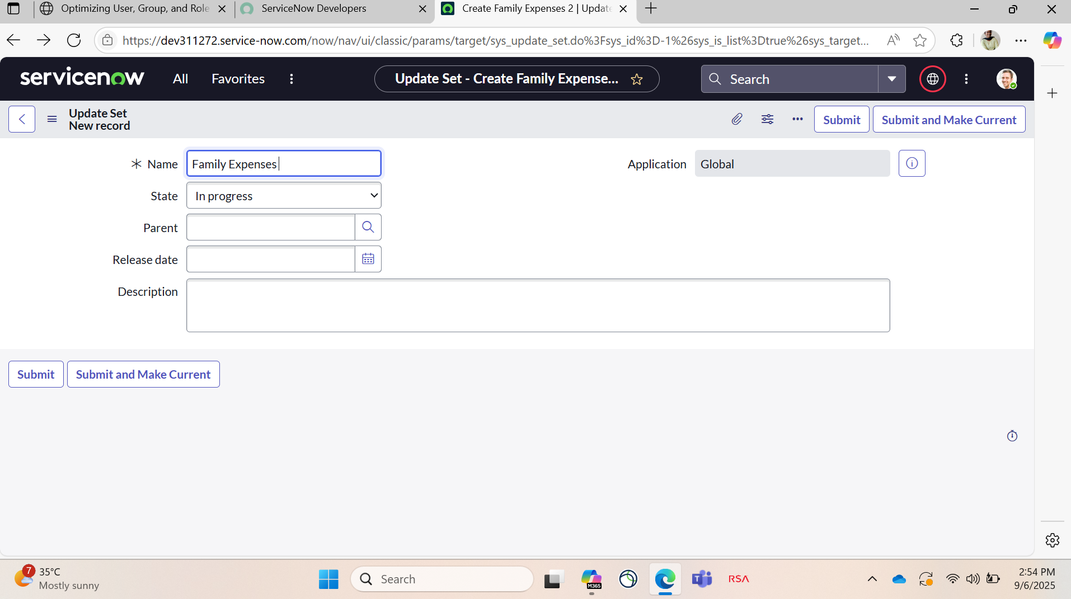

**Milestone 3: Creation Of Table**

**Activity 1:** **Creation of Family Expenses Table**

1. Go to "All" in the Application Navigator.
2. In the filter navigator, search for "Tables".
3. Select "Tables" under the System Definition module.
4. Click on "New" to create a new table.
5. Enter the following details:
6. Label: Family Expenses
7. Name: *(Auto-populated based on the label)*
8. New Menu Name: Family Expenditure
9. Go to the header, right-click, and then click "Save".

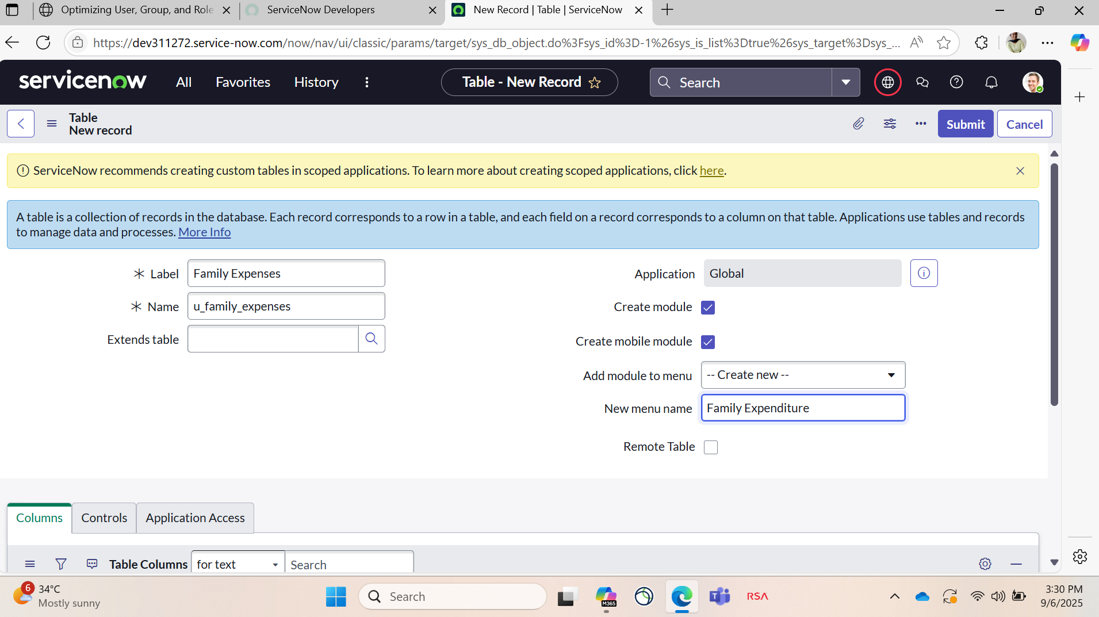

**Activity 2: Creation Of Column (Fields)**

1. Scroll to the "Columns" section of the table form.
2. Double-click near "Insert a new row" to add a new field.

* Column Label: Number
* Type: String

1. Double-click again near "Insert a new row" to add another field.

* Column Label: Date
* Type: Date

1. Double-click again near "Insert a new row" to add another field.

* Column Label: Amount
* Type: Integer

1. Double-click again near "Insert a new row" to add another field.

Column Label: Expenses Details

* Type: String
* Max Length: 800

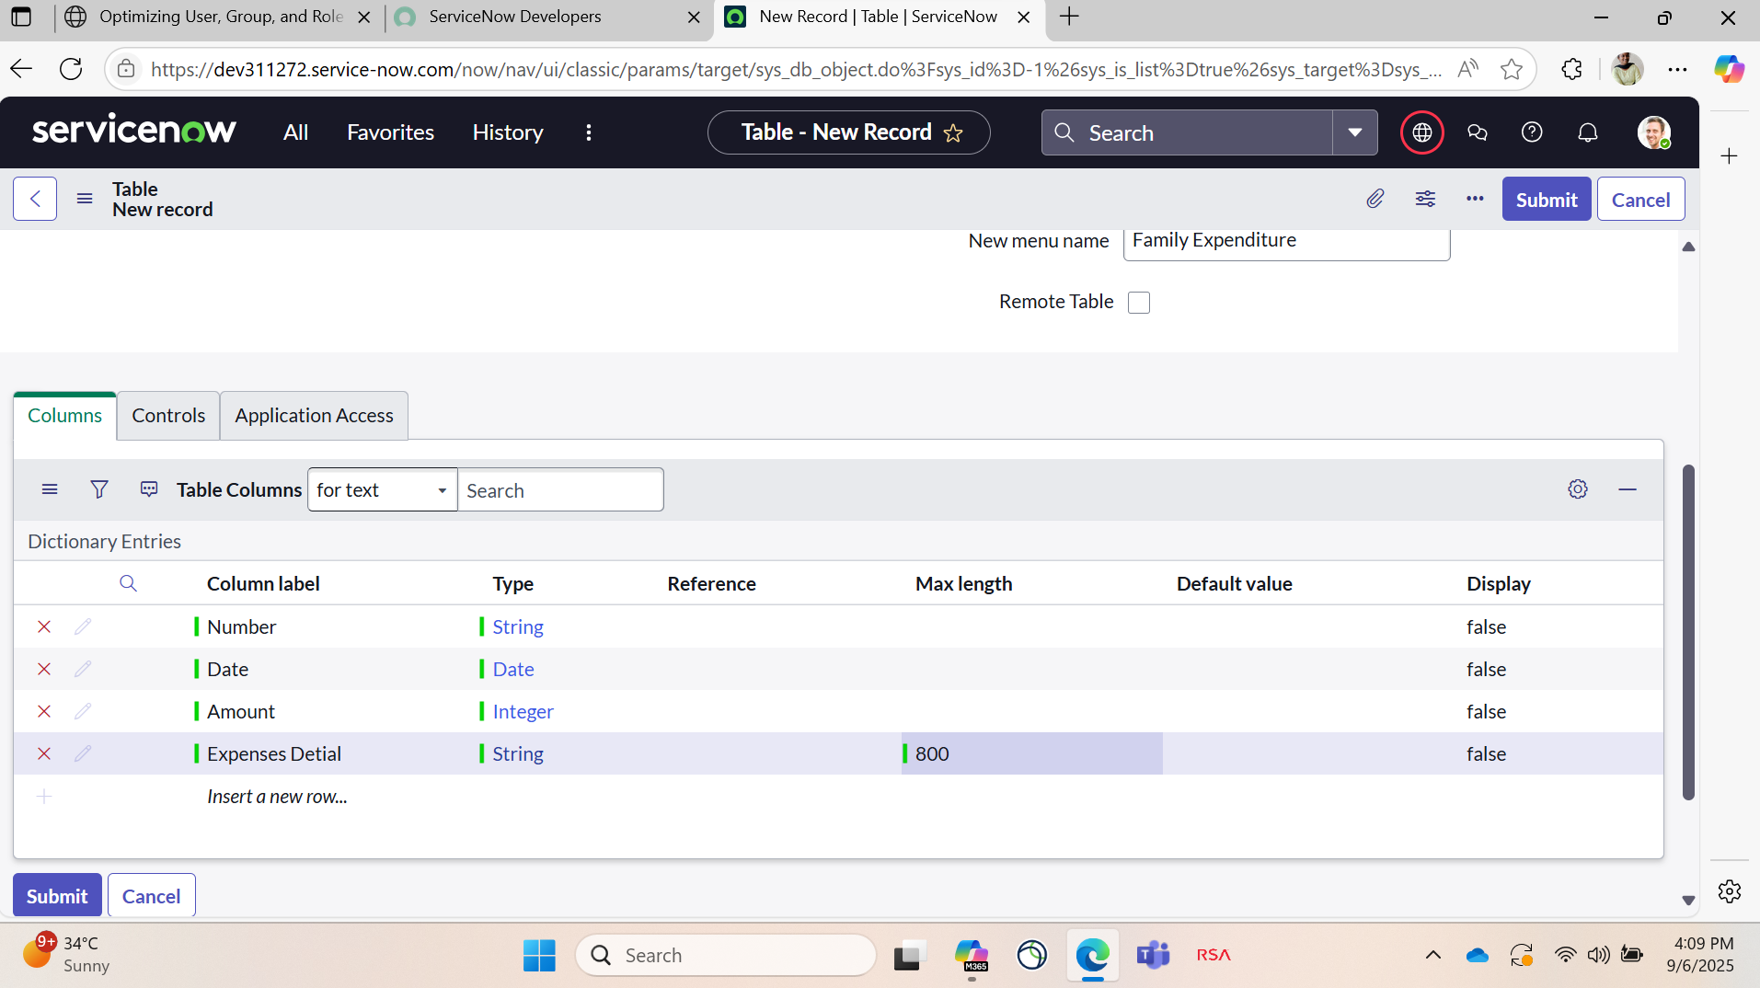

**Activity 3: Making Number Field An Auto-Number**

1. Double-click near "Insert a new row" to add a new field.

* Column Label: Family Member Name
* Type: Reference
* Max Length:800

2.Double-click near "Insert a new row" to add a new field.

* Column Label: Comments
* Type: String
* Max Length:800

3.Go to the Header and right click there>>Click on Save

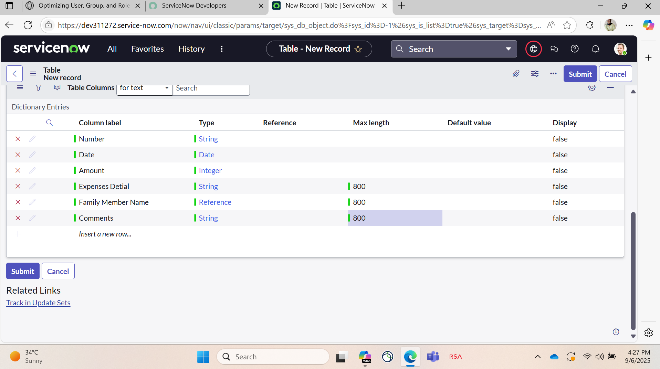

**Activity 4: Configure The Figure**

1. Go to "All" in the Application Navigator.
2. In the filter navigator, search for "Daily Expenses".
3. Open the "Daily Expenses" module.
4. Click on "New" to open a new record form.
5. Go to the form header, right-click, then click on "Configure" → "Form Design".
6. Customize the form layout by dragging and dropping the required fields.
7. Set the following field properties:
8. Make "Number" a Read-Only field.
9. Make "Date" and "Family Member" Mandatory fields.
10. Click "Save" to apply the changes.

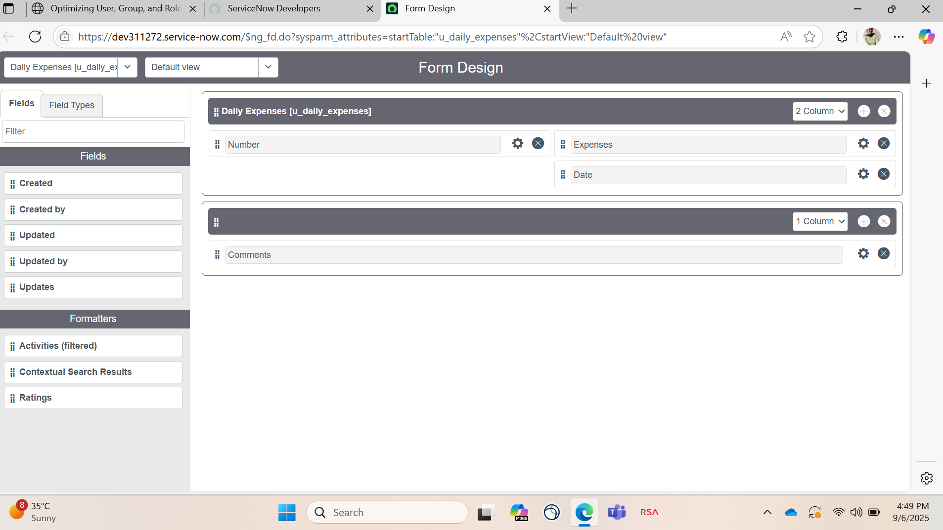

**Milestone 4: Creation Of Relationship**

**Activity 1: Creation Of Relationship Family Expenses and Daily Expenses Tables**

1. Go to: All >>
2. Use the filter to search for "Relationships"
3. Open the Relationships section
4. Enter the following details:
5. Name: Daily Expenses
6. Applies to Table: Family Expenses
7. Daily Expenses: Select Family Expenses from the dropdown
8. Click on Save

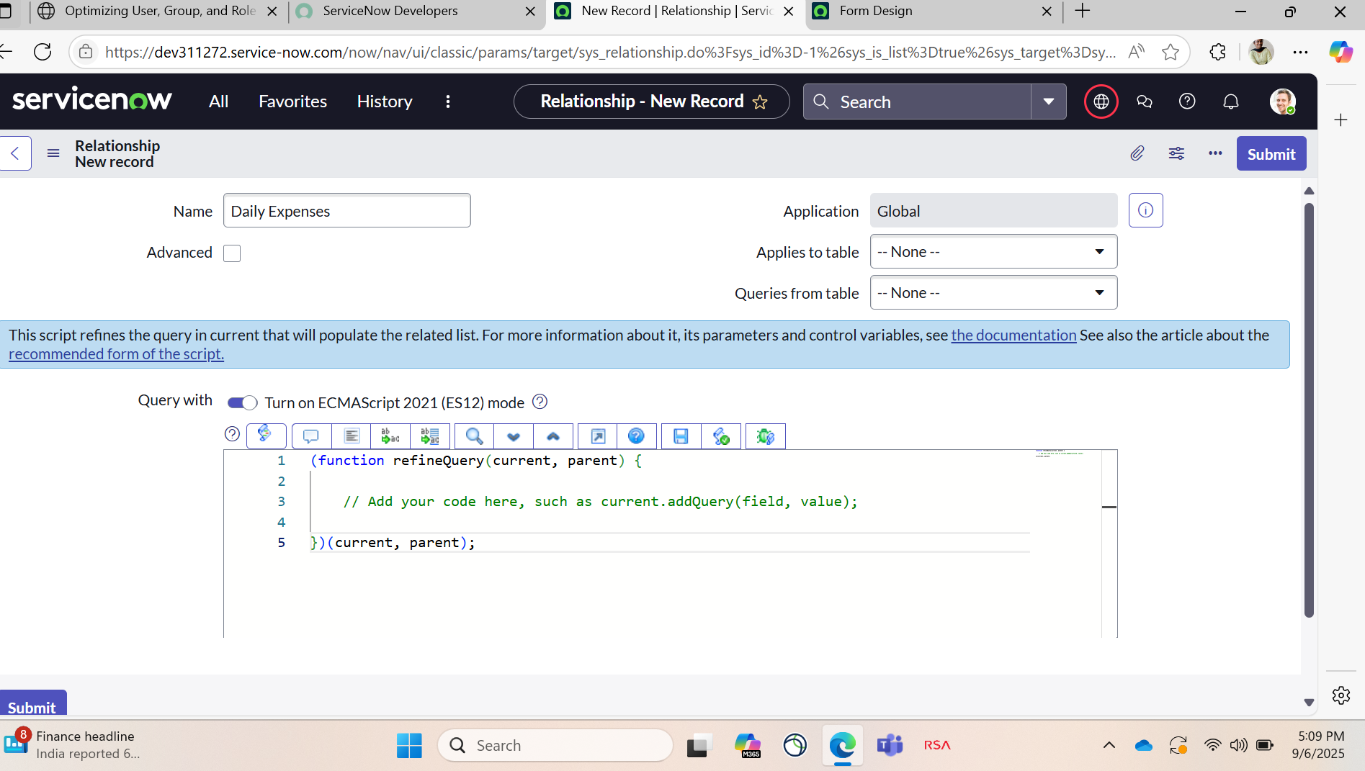

**Milestone 5: Configuring Related List on Family Expenses**

**Activity 1: Configuring Related List on Family Expenses**

1. Go to: All >>
2. In the filter, search for "Family Expenses"
3. Open the Family Expenses record
4. Click on New
5. Go to the header, right-click on it
6. Select Configure >> Related Lists
7. Add Daily Expenses to the Selected Area
8. Click on Save

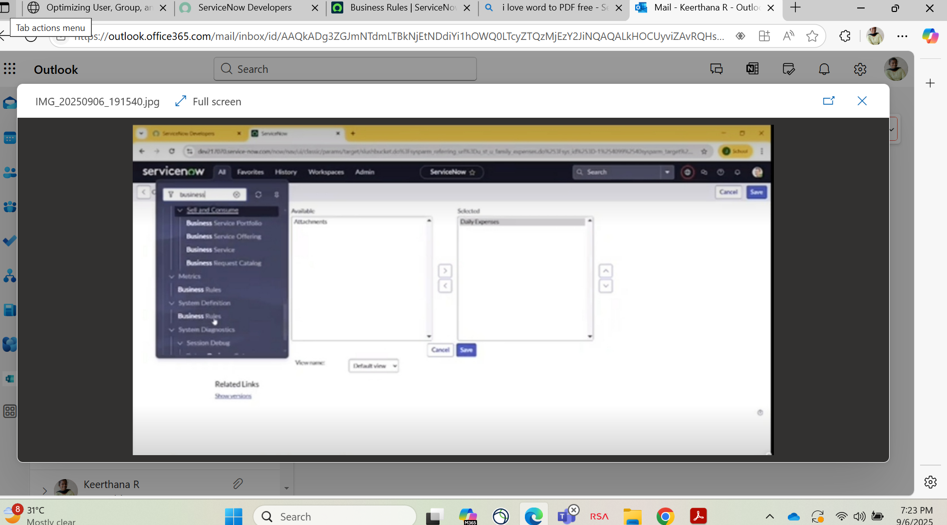

## **Milestone 6: Creation Of Business Rules**

## **Activity 1:** **Creation Of Business Rules**

## Go to All>>

1. In the filter, search for "Business Rules"
2. Under System Definition, select Business Rules, then click on New
3. Enter the following details:
4. Name: Family Expenses BR
5. Table: Select Daily Expenses
6. Check the Advanced option
7. Under When to Run, check both Insert and Update
8. Click on Save

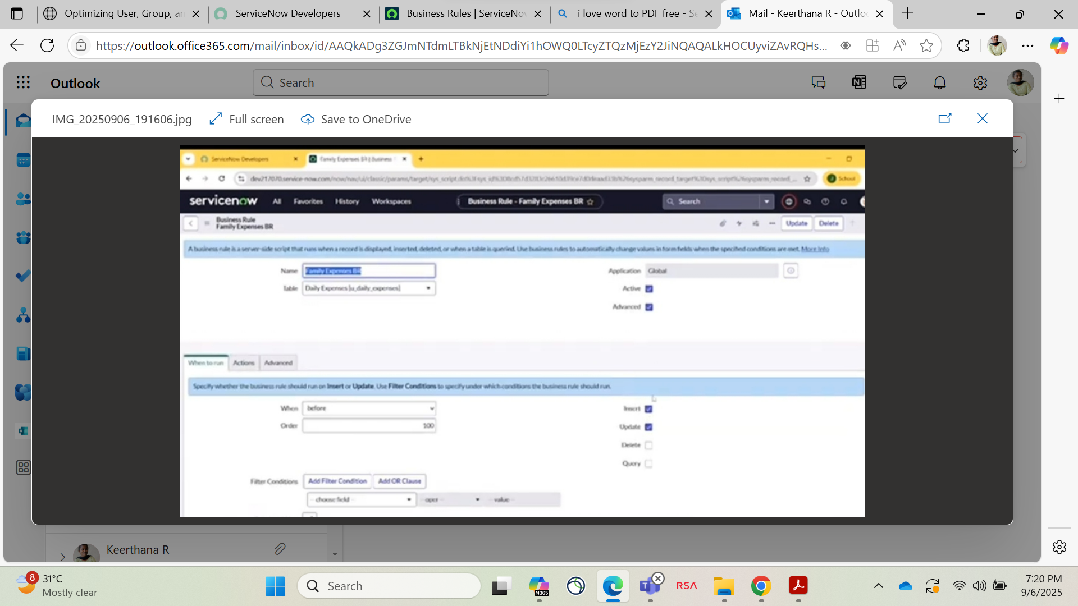

**Milestone 7: Configure The Relationships**

**Activity 1: Configure The Relationships**

1. Go to ALL>> in the filter search for relationships >>open Relationships
2. In that, open daily expensive Relationships
3. For applies to table: select family expenses
4. In query with write the below query
5. Click on update

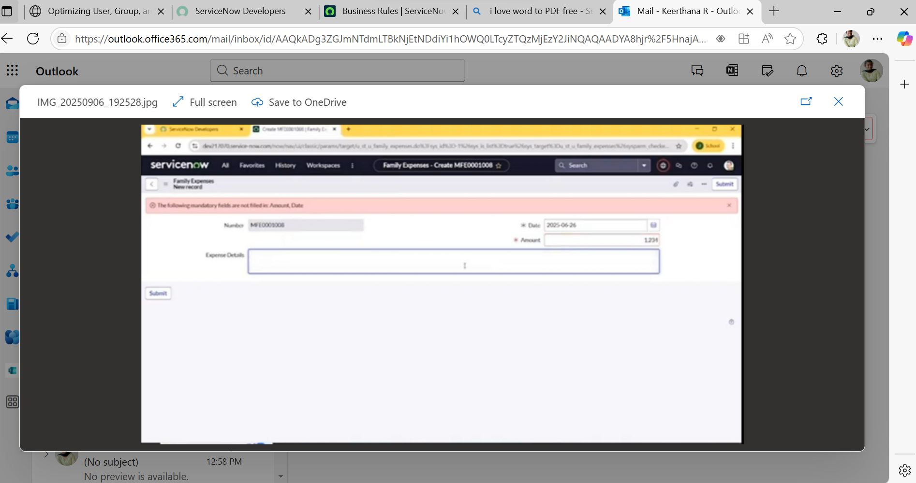

**Conclusion:**

The project “Calculating Family Expenses Using ServiceNow” successfully demonstrates how a powerful ITSM platform like ServiceNow can be adapted beyond traditional IT workflows to manage and track personal or household financial data. By leveraging features such as custom tables, relationships, and business rules, we created a structured and automated system to record, relate, and monitor daily expenses under a centralized Family Expenses module.

This approach not only improves data visibility and accuracy but also enables real-time tracking, reporting, and scalability for future enhancements like notifications, dashboards, or integrations with external financial tools. Overall, this project highlights the flexibility of ServiceNow in solving real-world problems beyond enterprise IT, making it a valuable tool for both professional and personal process automation.